**CSE360**

**Software Engineering Lab**



**Requirements Analysis**

**Report on**

**“ Travel Application ”**

Group member info: 20CSE025, 20CSE002, 20CSE024

**Table of Contents**

1. **Introduction** ............................................................................................................................ 4  
1.1 System Purpose ............................................................................................................................ 4  
1.2 System Scope ................................................................................................................................ 5  
1.3 Process Model .............................................................................................................................. 5

2. **Research** .................................................................................................................................. 6  
2.1 Market Analysis ............................................................................................................................ 6  
2.2 User Surveys and Interviews ........................................................................................................ 7  
2.3 Competitive Analysis .................................................................................................................... 7  
2.4 Technology Trends ....................................................................................................................... 7  
2.5 Literature Review ......................................................................................................................... 8

3. **Description** ............................................................................................................................. 8  
3.1 User Registration and Profile Management ................................................................................. 9

3.2 Search and Booking ...................................................................................................................... 9  
3.3 Itinerary Management ................................................................................................................. 9  
3.4 Real-Time Updates and Notifications ........................................................................................... 9  
3.5 Personalized Recommendations .................................................................................................. 9  
3.6 Secure Payment Gateway ............................................................................................................. 9  
3.7 Customer Support ........................................................................................................................ 9

4. **Requirements** ..........................................................................................................................9  
4.1 Functional Requirements .............................................................................................................10  
4.1.1 User Registration and Profile Management ..............................................................................10  
4.1.2 Search and Booking ...................................................................................................................10  
4.1.3 Itinerary Management ...............................................................................................................10  
4.2 Non-Functional Requirements ..................................................................................................... 11  
4.2.1 Performance ..............................................................................................................................11  
4.2.2 Security ......................................................................................................................................11  
4.2.3 Usability .....................................................................................................................................11

5. **System Analysis and Modeling** ...................................................................................... 12  
5.1 System Architecture .................................................................................................................... 12  
5.2 Data Flow Diagrams (DFD) .......................................................................................................... 12  
5.2.1 Level 0 DFD .............................................................................................................................. 12  
5.2.2 Level 1 DFD .............................................................................................................................. 14  
5.3 Use Case Diagrams ......................................................................................................................15

1. **Introduction**

The objective of this project is to develop a comprehensive travel app that simplifies the process of planning and booking travel, offering users a seamless experience from start to finish. The app aims to cater to a wide range of travelers, including solo adventurers, families, and business travelers, providing features such as flight and hotel bookings, itinerary management, and local activity recommendations.

1. **1 System Purpose**

The purpose of the travel app system is to provide users with a seamless and comprehensive travel planning and booking experience. It aims to simplify travel planning by offering a one-stop solution for booking flights, hotels, car rentals, and local activities. The app will utilize AI to provide personalized travel recommendations, offer real-time updates on travel statuses, ensure secure transactions, and provide 24/7 customer support. By addressing common travel challenges, the app aims to enhance the overall travel experience for users.

**1. 2 System Scope**

The scope of the app includes:

1. **User-Friendly Interface**: Ensuring an intuitive and easy-to-navigate design that enhances user experience.
2. **Comprehensive Booking System**: Allowing users to book flights, hotels, car rentals, and local activities all in one place.
3. **Personalized Recommendations**: Utilizing AI to offer tailored travel suggestions based on user preferences and past behavior.
4. **Real-Time Updates**: Providing real-time notifications and updates on flight statuses, hotel check-ins, and local events.
5. **Secure Transactions**: Implementing robust security measures to protect user data and ensure safe transactions.
6. **Customer Support**: Offering 24/7 customer support to assist users with any issues or queries.

This project aims to address the common pain points faced by travelers, such as the hassle of managing multiple bookings, lack of personalized travel suggestions, and the need for real-time updates. By integrating these features into a single app, we aim to provide a convenient and enjoyable travel planning experience for users.

**1. 3 Process Model**

The process model for the travel app involves several key stages:

1. **Requirement Analysis**: Gather and analyze requirements from stakeholders to define the app's functionalities and features.
2. **System Design**: Design the architecture, database schema, and user interface of the app.
3. **Development**: Implement the design into a working app, including coding and integrating third-party services.
4. **Testing**: Ensure the app functions correctly through functional, integration, performance, and user acceptance testing.
5. **Deployment**: Launch the app to the target audience and monitor for any issues.
6. **Maintenance and Updates**: Provide ongoing support, fix bugs, and release updates to improve the app.

This process model ensures a structured approach to developing the travel app, covering all essential stages from requirement analysis to maintenance and updates.

1. **Research**

The research phase of the travel app project involves gathering and analyzing information to ensure the app meets user needs and stands out in the competitive market. Here are the key components of the research:

**2.1 Market Analysis**

1. **Objective**: Understand the current market trends, user preferences, and competitive landscape.
2. **Activities**:
   1. Analyze existing travel apps to identify their strengths and weaknesses.
   2. Study market trends, such as the rise of eco-tourism and personalized travel experiences.
   3. Identify target audience segments, including solo travelers, families, and business travelers.

**2. 2 User Surveys and Interviews**

1. **Objective**: Gather insights directly from potential users to understand their needs, preferences, and pain points.
2. **Activities**:
   1. Conduct online surveys to collect quantitative data on user preferences and behaviors.
   2. Organize focus group discussions and one-on-one interviews to gather qualitative insights.
   3. Analyze feedback to identify common themes and areas for improvement.

**2.3 Competitive Analysis**

1. **Objective**: Evaluate the features and performance of existing travel apps to identify opportunities for differentiation.
2. **Activities**:
   1. Review top travel apps like Booking.com, Expedia, and Airbnb.
   2. Compare features, user interfaces, and customer reviews.
   3. Identify gaps in the market that the new travel app can address.

**2.4 Technology Trends**

1. **Objective**: Explore the latest technologies that can enhance the travel app's functionality and user experience.
2. **Activities**:
   1. Research advancements in AI for personalized recommendations and chatbots.
   2. Investigate the use of augmented reality (AR) for virtual tours and immersive experiences.
   3. Explore blockchain technology for secure transactions and data privacy.

**2.5 Literature Review**

1. **Objective**: Review academic papers, industry reports, and case studies related to travel apps and technology.
2. **Activities**:
   1. Summarize key findings from relevant research papers and reports.
   2. Identify best practices and innovative approaches in travel app development.
   3. Apply insights from the literature to inform the app's design and features.

By conducting thorough research, the travel app project aims to create a user-centric and innovative solution that addresses the needs of modern travelers and leverages the latest technological advancements.

### ****Description****

The travel app is designed to provide users with a seamless and comprehensive travel planning and booking experience. Here are the key features and functionalities of the app:

#### ****3.1 User Registration and Profile Management****

1. **User Registration**: Users can sign up using their email, social media accounts, or phone numbers. They can create a profile with personal details and travel preferences.
2. **Profile Management**: Users can update their profiles, save travel preferences, and manage their travel history.

#### **3.2 Search and Booking**

1. **Flight Booking**: Users can search for and book flights from various airlines. The app provides options to filter results based on price, duration, and layovers.
2. **Hotel Booking**: Users can search for and book hotels, with options to filter by price, location, amenities, and user ratings.
3. **Car Rentals**: Users can book car rentals for their trips, with options to choose from different car types and rental companies.
4. **Local Activities**: Users can discover and book local activities and experiences, such as tours, events, and attractions.

#### **3.3 Itinerary Management**

1. **Itinerary Creation**: Users can create and manage their travel itineraries, including flight details, hotel reservations, and planned activities.
2. **Itinerary Sharing**: Users can share their itineraries with friends and family via email or social media.

#### **3.4 Real-Time Updates and Notifications**

1. **Flight Status**: Users receive real-time updates on flight statuses, including delays, cancellations, and gate changes.
2. **Hotel Check-Ins**: Users receive notifications about hotel check-in times and any special instructions.
3. **Local Events**: Users receive updates on local events and activities happening during their travel dates.

#### **3.5 Personalized Recommendations**

1. **AI-Powered Suggestions**: The app uses AI to provide personalized travel recommendations based on user preferences, past behavior, and current trends.
2. **Custom Travel Plans**: Users can receive custom travel plans tailored to their interests and preferences.

#### **3.6 Secure Payment Gateway**

1. **Multiple Payment Options**: The app supports various payment methods, including credit/debit cards, digital wallets, and bank transfers.
2. **Secure Transactions**: The app implements robust security measures to protect user data and ensure safe transactions.

#### **3.7 Customer Support**

1. **24/7 Support**: The app offers round-the-clock customer support through chat, email, and phone.
2. **Help Center**: Users can access a help center with FAQs, guides, and troubleshooting tips.

### **4. Requirements**

The requirements for the travel app project are divided into functional and non-functional requirements. These requirements ensure that the app meets user needs and provides a seamless travel planning and booking experience.

#### **4.1 Functional Requirements**

1. **User Registration and Profile Management**:
   1. Users can sign up using email, social media accounts, or phone numbers.
   2. Users can create and update profiles with personal details and travel preferences.
2. **Search and Booking**:
   1. Users can search for flights, hotels, car rentals, and local activities.
   2. Users can filter search results based on price, duration, location, and user ratings.
   3. Users can book flights, hotels, car rentals, and activities through the app.
3. **Itinerary Management**:
   1. Users can create and manage travel itineraries, including flight details, hotel reservations, and planned activities.
   2. Users can share itineraries with friends and family via email or social media.
4. **Real-Time Updates and Notifications**:
   1. Users receive real-time updates on flight statuses, hotel check-ins, and local events.
   2. Users receive notifications about delays, cancellations, and gate changes.
5. **Personalized Recommendations**:
   1. The app uses AI to provide personalized travel recommendations based on user preferences and past behavior.
   2. Users receive custom travel plans tailored to their interests and preferences.
6. **Secure Payment Gateway**:
   1. The app supports various payment methods, including credit/debit cards, digital wallets, and bank transfers.
   2. The app implements robust security measures to protect user data and ensure safe transactions.
7. **Customer Support**:
   1. The app offers 24/7 customer support through chat, email, and phone.
   2. Users can access a help center with FAQs, guides, and troubleshooting tips.

#### **4.2 Non-Functional Requirements**

1. **Performance**:
   1. The app should load quickly and handle high traffic efficiently.
   2. The app should provide a smooth and responsive user experience.
2. **Security**:
   1. The app should implement strong encryption and security protocols to protect user data.
   2. The app should comply with data protection regulations and standards.
3. **Usability**:
   1. The app should have an intuitive and user-friendly interface.
   2. The app should be accessible to users with different levels of technical expertise.
4. **Compatibility**:
   1. The app should be compatible with both iOS and Android devices.
   2. The app should support various screen sizes and resolutions.
5. **Scalability**:
   1. The app should be able to scale to accommodate a growing number of users and transactions.
   2. The app should support future updates and feature enhancements.

5. System Analysis and Modeling

System analysis and modeling are crucial steps in the development of the travel app. These processes help in understanding the system requirements, designing the architecture, and ensuring that all components work together seamlessly. Here are the key components:

5.1 System Architecture

**Client-Server Model**: The app will follow a client-server architecture where the client (mobile app) interacts with the server (backend) to fetch and store data.

**Backend Services**: The backend will handle user authentication, data storage, booking management, and real-time updates. It will be built using scalable cloud services.

**Database Design**: A relational database will be used to store user profiles, bookings, itineraries, and transaction details. The database will be optimized for fast retrieval and secure storage.

Data Flow Diagrams (DFD)

**5.2.1 Level 0 DFD:**

This diagram provides a high-level overview of the system, showing the main processes and data flows between the user, the app, and external services (e.g., payment gateways, airline APIs).

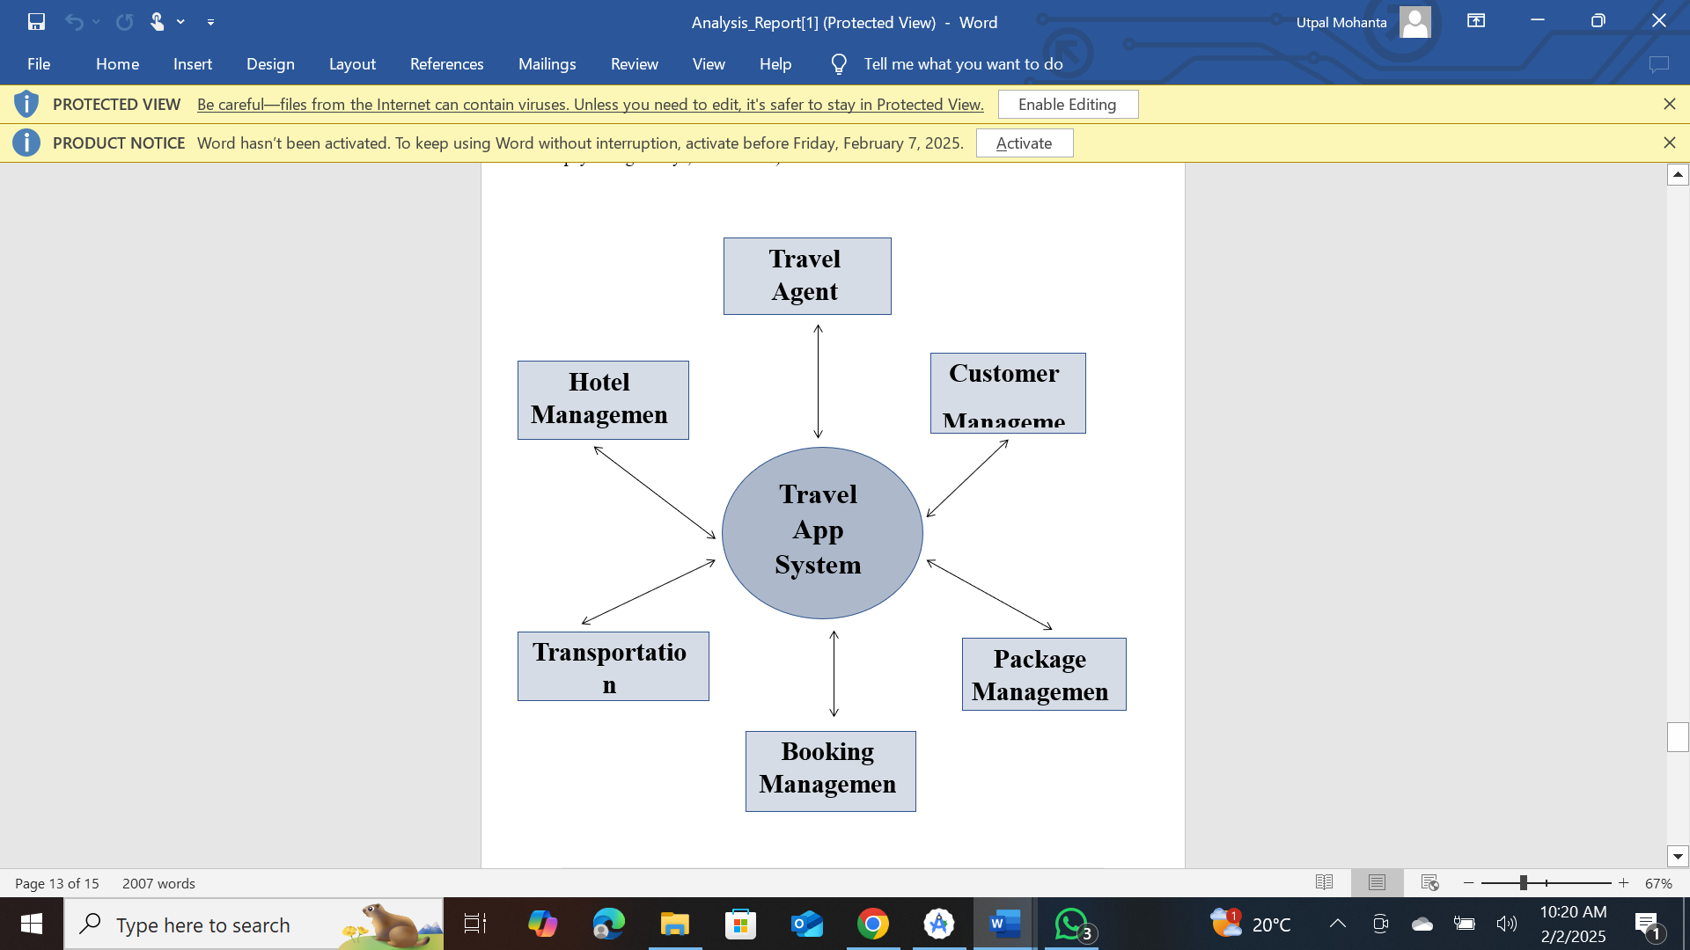

**5.2.2 Level 1 DFD:**

This diagram breaks down the main processes into sub-processes, detailing how data moves through the system. For example, the booking process can be divided into search, selection, payment, and confirmation sub-processes.

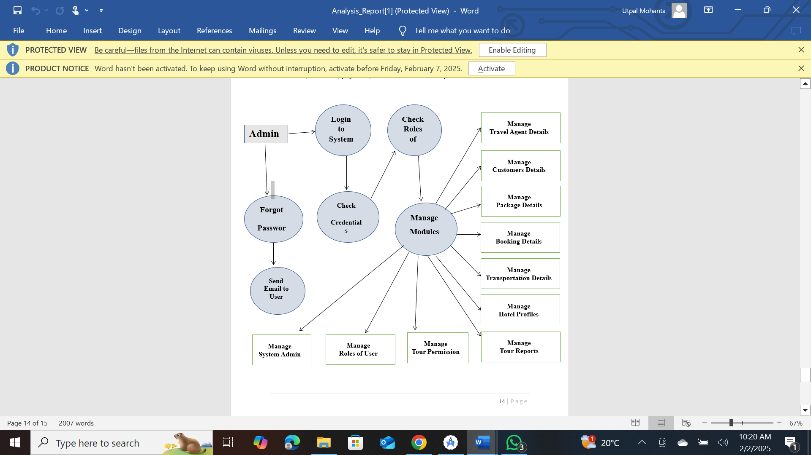

5.3 Use Case Diagrams

**User Interactions**: Use case diagrams illustrate the interactions between users and the app. Key use cases include user registration, flight booking, hotel booking, itinerary management, and customer support.

**Actors**: The primary actors are the users (travelers) and the system (app). Secondary actors include external services like payment gateways and airline APIs.